Name : Sundaramoorthy S
Reg No : 192324228
Course code : Cloud Computing And Big Data Analysis
Exp No : EXPERIMENT 1
Date : 18/12/2025
EXPERIMENT 1
Title: Creation of a Simple Cloud Software Application to Demonstrate SaaS
Aim
To create and deploy a simple cloud-based software application and provide it as a service using a Cloud Service Provider to demonstrate Software as a Service (SaaS).
Procedure
- Select a cloud service provider such as AWS / Azure / Google Cloud.
- Create a simple web application for user subscription management.
- Design a database to store user details and subscription plans.
- Deploy the application on the cloud server.
- Allow users to access the application through a web browser.
- Store and retrieve user data from the cloud database.
Output
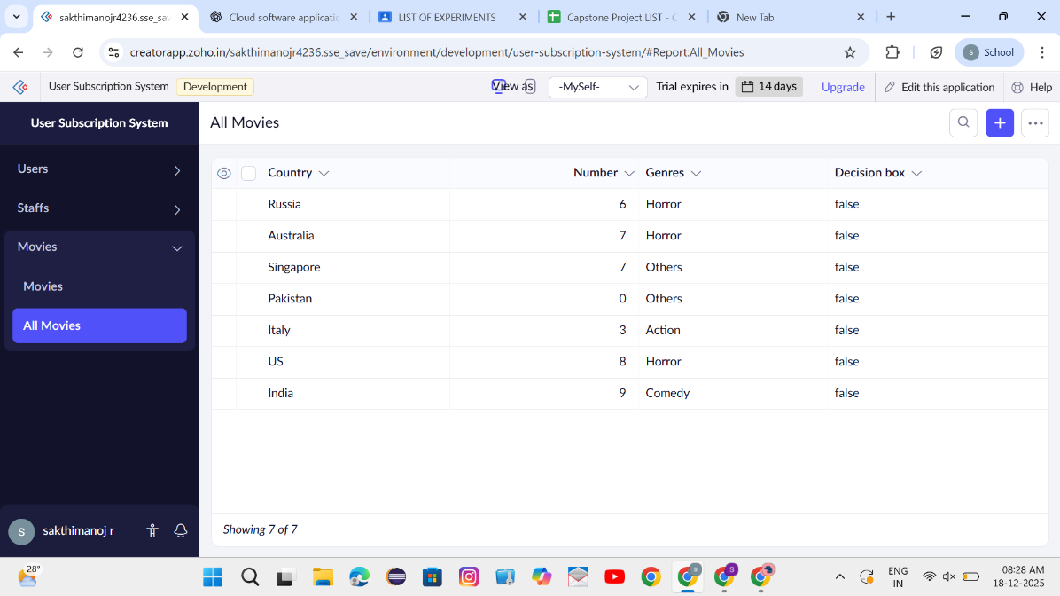
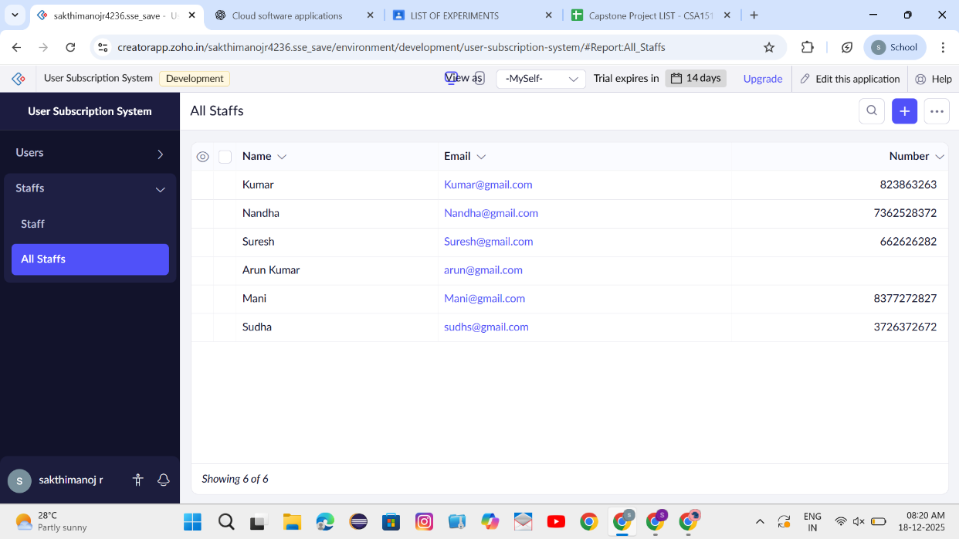

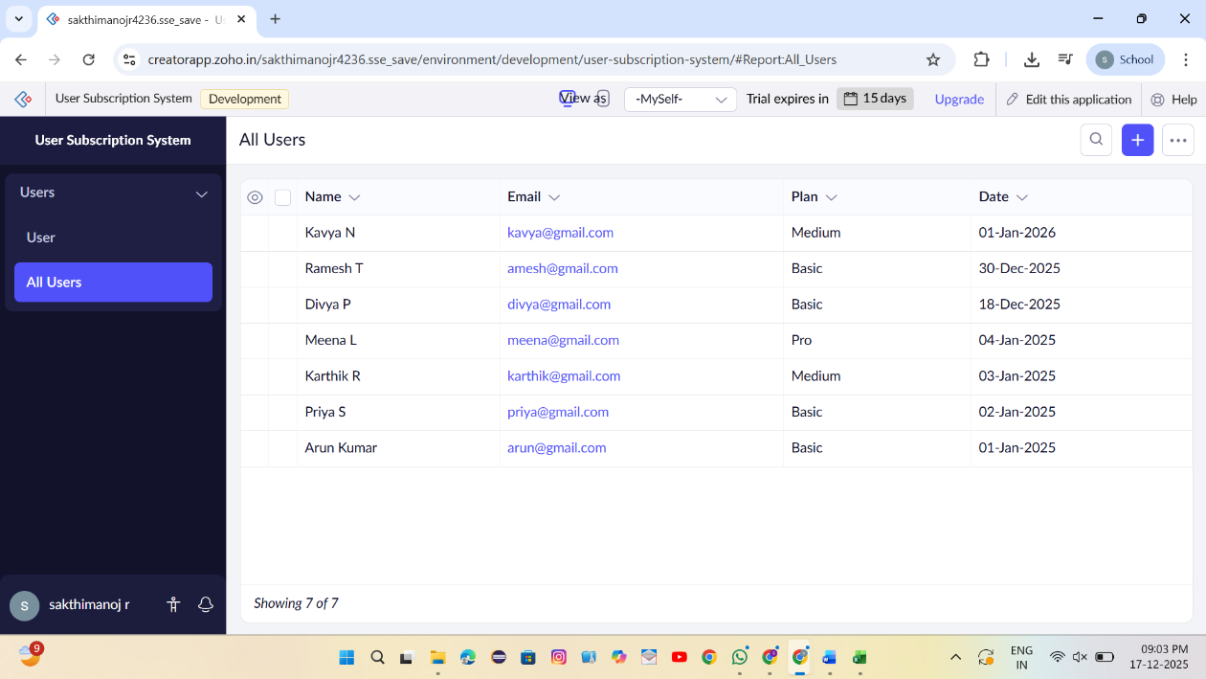

Result
Thus, a simple cloud software application was successfully created and deployed to demonstrate Software as a Service (SaaS).

